Toktrapport / Havforskningsinstituttet / ISSN x-x / Nr. x – 2012

REPORT FROM SURVEYS TO ASSESS HARP AND HOODED SEAL PUP PRODUCTION IN THE GREENLAND SEA PACK-ICE IN 2012

Tore Haug, Kjell Tormod Nilssen and Tor Arne Øigård

Institute of Marine Research (IMR), PO Box 6404, N-9294 Tromsø, Norway

SUMMARY

In the period 18 March to 1 April 2012 aerial surveys were performed in the Greenland Sea pack-ice (the West Ice), to assess the pup production of the Greenland Sea populations of harp (Pagophilus groenlandicus) and hooded (Cystophora cristata) seals. Two fixed-wing aircrafts, stationed in Constable Pynt (East-Greenland) and Akureyri (Iceland), were used for reconaissance flights and photographic surveys along transects over the whelping areas. A helicopter, operated from the applied expedition vessel (M/V”Nordsyssel”) also flew reconnaissance flights, and was subsequently used for monitoring the distribution of seal patches and age-stageing of the pups.

The reconnaissance surveys were flown by the helicopter (18 March - 1 April) and the fixed-wing aircrafts (22 March – 1 April) in an area along the eastern ice edge between 67°55’and 74°10’N. Obviously, the ice cover was narrow and the edge close to the Greenland coast in 2012. The reconnaissance surveys were adapted to the actual ice configuration, usually flown at altitudes ranging from 160 - 300 m. Repeated systematic east-west transects spacing10 nm (sometimes 5 nm apart) were flown from the eastern ice edge and usually 20-30 nautical miles (sometimes longer) over the drift ice to the west. Harp seal breeding was first observed on 19 March in an area between 73º00’N and 73º18’N; 14º28’W and 15º05’W (Patch A) and on 21 March in area between 72º00’N and 72º25’N; 15º30’W and 17º00’W (Patch B). Subsequent helicopter age-stageing flights in the tho patches confirmed substantially increase in the number of whelping harp seals in patch B which was also observed to include increasing numbers of whelping hooded seals to the east (i.e., closer to the ice edge) of the harp seals. The general drift of the two patches were in a south westerly direction. Due to more scattered and open drift ice in patch A, this patch drifted faster than patch B. Thus, on 28 March the two patches had merged, yielding one large patch. Outside the localized whelping patches no apparent harp seal breeding was observed, only a few scattered hooded seal families and, subsequently, solitary bluebacks were observed in the northeast.

Both aircrafts were equipped with Vexcel Ultracam Xp digital cameras, which provided multichannel images (Red Green Blue Infrared). On 28 March, a total of 27 photo transects, spacing 3 nautical miles, were flown using both aircrafts in the area between 70º43’N / 18º 31’ - 18º 15’ W and 72º 01’N / 17º 29’ - 17º 29 W. The survey covered the entire area of the merged patches A and B. All transects were flown with cameras operating to ensure about 80-90 % coverage of the area along each transect line, resulting in a total of 2792 photos shot.

The results from the aerial surveys will be used to estimate the 2012 harp and hooded seal pup production in the West Ice. Subsequently, the status of the stocks will be assessed by fitting the pup production estimates to population models.

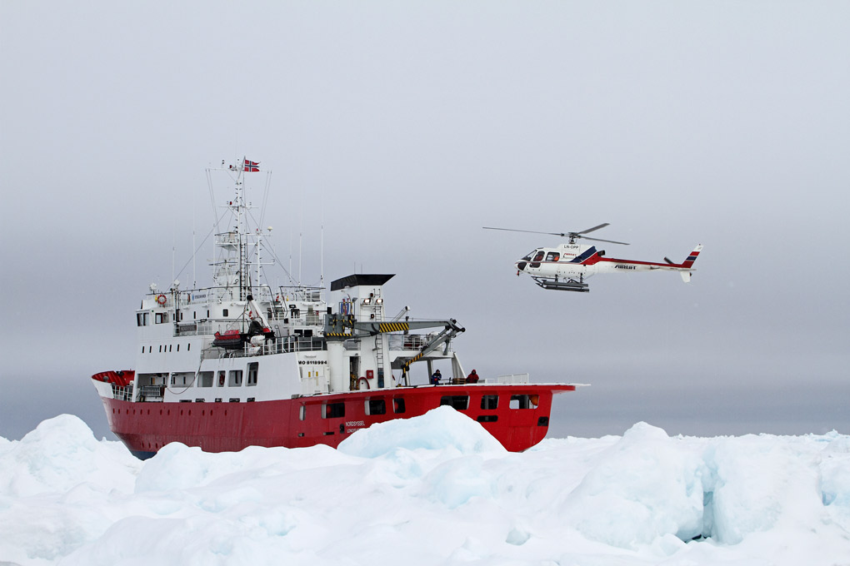

(Photo: Eirik Grønningsæter, WildNature.no)

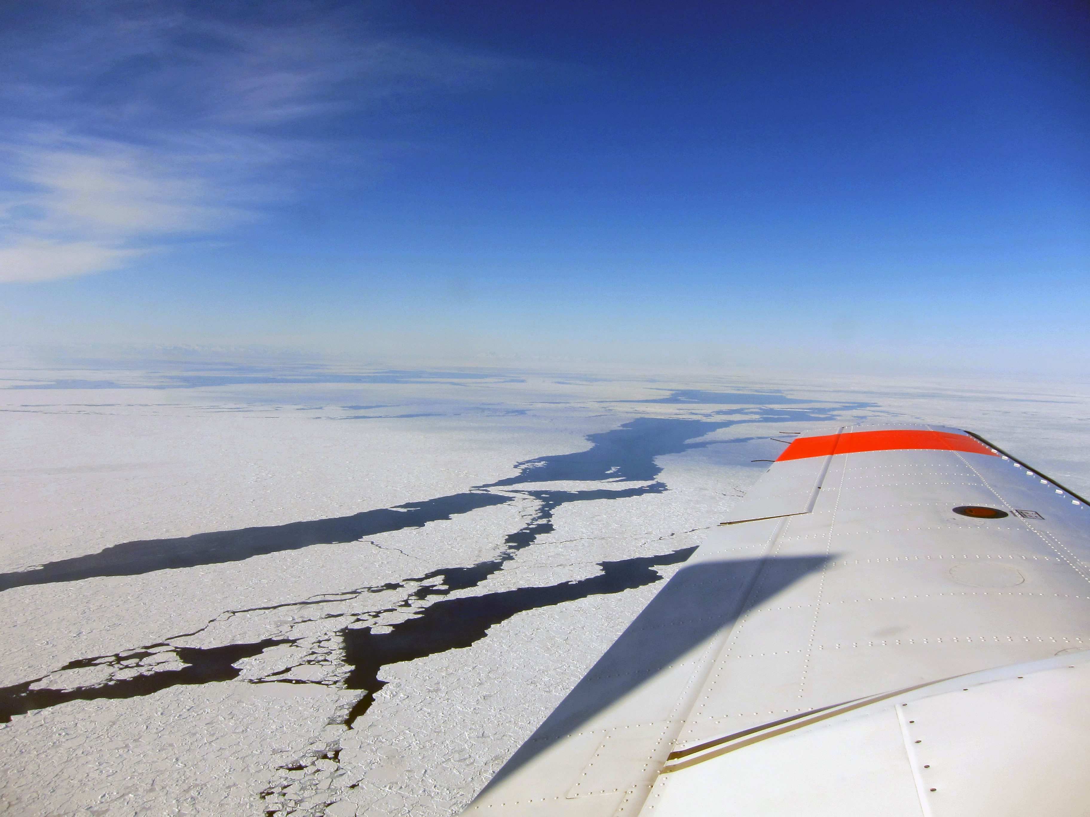

(Photo: Kjell Arne Fagerheim, Institute of Marine Research)

1 INTRODUCTION

Due to uncertainties in the assumptions required when estimating abundance from catch-at-age data, sequential population models and mark-recapture data, independent estimates of pup production, using aerial photo or visually based strip transect methods, have been recommended and used to determine population size of harp (Pagophilus groenlandicus) and hooded (Cystophora cristata) seals both in the northwest Atlantic (Bowen et al., 1987; Hammill et al., 1992; Stenson et al., 1993; 1997; 2002; 2003; 2005; 2006; 2010), in the Greenland Sea (Øritsland and Øien, 1995; Haug et al., 2006; ICES, 2006a; Salberg et al. 2008; Øigård et al 2010), and in the White Sea (Potelov et al., 2003; ICES, 2011). The status of the stocks are subsequently assessed by fitting population models to the independent estimates of pup production (e.g. Healey and Stenson, 2000; Hammill and Stenson, 2007; Skaug et al., 2007; ICES 2011).

Both harp and hooded seal pup production was last assessed in the Greenland Sea in 2007 (Øigård et al. 2010). The ICES management of harp and hooded seals require that these populations are defined as “data rich” (ICES 2006b). Data rich stocks should have data available for estimating abundance where a time series of at least three abundance estimates should be available spanning a period of 10-15 years with surveys separated by 2-5 years. The most recent abundance estimates should be prepared from surveys and supporting data (e.g., birth and mortality estimates) that are no more than 5 years old. Therefore, the plan was to conduct new surveys to obtain data necessary for estimation of the abundance of harp and hooded seals of the Greenland Sea stocks in 2012. In addition to revisit all areas historically used by harp and hooded seals for breeding purposes in the Greenland Sea (see Haug et al. 2006; Salberg et al. 2008; Øigård et al. 2010), also new areas to the north and south of these areas were covered with reconnaissance flights during the survey. The survey techniques applied were as decribed in Øigård et al. (2010).

The harp seal was the prime target species for the surveys since this population is still hunted. Hooded seals have been protected since 2007 due to the low pup production numbers (ICES 2006a; 2011) – to assess the effect of protection on the pup production, more than 5 years are needed due to the usually 4-5 years age at maturity observed in hooded seals (see Frie et al. 2012). If possible, however, it was a secondary goal to obtain also a new abundance estimate for hooded seals in the area during the same survey. Evidently, given the available logistical resources and the priority of harp seals, the possibilities to obtain a hooded seal pup production estimate would require that hooded seal breeding occurred within the same main areas as the harp seal breeding. During the course of the survey, it proved possible to obtain data on the pup production of both harp and hooded seals in the Greenland Sea in 2012. In addition to give a short review of the status of the Greenland Sea harp and hooded seal populations, the present report review the activities on the ship bound part of the survey (including all activities using the ship bourne helicopter) and details from the activities of two aircrafts used for reconnaissance and photographic surveys.

2 STATUS OF THE SEAL STOCKS

2.1 HARP SEALS

Three stocks of harp seals inhabit the North Atlantic Ocean (Sergeant 1991). Whelping occurs east of Newfoundland and in the Gulf of St.Lawrence (the Northwest Atlantic stock), off the east coast of Greenland (the Greenland Sea or West Ice stock), and in the White Sea (the Barents Sea / White Sea stock). Relationships among the three North Atlantic populations of harp seals have been examined in studies of cranial measurements (Yablokov and Sergeant 1963), underwater vocalizations (Perry and Terhune 1999), serum transferrins (Møller et al., 1966; Nævdal, 1966; 1969; 1971), blood serum proteins (Borisov, 1966), allozymes (Meisfjord and Nævdal 1994) and DNA (Meisfjord and Sundt, 1996; Perry et al. 2000). These studies have revealed significant differences between the Northwest Atlantic stock on one side and the Greenland Sea and Barents Sea harp seal stocks on the other, while no evidence of difference between the two latter was observed. In late summer (July-August) seals from the Grenland Sea stock migrate into feeding grounds in the northern Barents Sea where they mingle with the Barents Sea stock before they return (in November-December) and spend the winter off south-east Greenland in the Denmark Strait (Folkow et al. 2004; Nordøy et al. 2008). Although tagging experiments suggest that mixing of immature animals between the West Ice and Barents Sea stocks may occur, there is no evidence of mixing on the breeding grounds (Øien & Øritsland 1995). The two stocks are managed separately.

The Greenland Sea stocks of harp seals have been subject to commercial exploitation for centuries (Iversen, 1927; Nakken, 1988; Sergeant, 1991). Exploitation levels reached a historical maximum in the 1870s and 1880s when annual catches of harp seals (pups and adults) varied between 50 000 and 120 000 (Iversen, 1927). It was evident that the catch levels in the 1870s were higher than the stock could sustain, and some regulatory measures (mainly designed to protect adult females) were taken in 1876 (Iversen, 1927). In the first decades of the 20th century the annual harp seal catches varied between 10 000 and 20 000 animals, whereas an increase to around 40 000 seals per year occurred in the 1930s (Iversen, 1927; Sergeant 1991). After a 5 year pause in the sealing operations during World War II, total annual catches quickly rose to a postwar maximum of about 70 000 in 1948, but then followed a decreasing trend until quotas were imposed in 1971 (Sergeant 1991, ICES 2001). From 1955 to 1994 a minor part of the catches were taken by the Soviet Union / Russia, and the total annual catches have varied between a few hundreds to about 17 000 from 1971 to present (ICES, 2011).

Available knowledge of both previous and present abundance of Greenland Sea harp seals is rather restricted. As judged both from catch per unit of effort analyses and mark-recapture pup production estimates, it has been assumed that the stock has increased ever since the early 1960s, but evidence of the level of increase has been rather imprecise (Ulltang and Øien, 1988; Øien and Øritsland, 1995). During the period 1977-1991, about 17 000 harp seal pups were tagged in a comprehensive mark-recapture experiment in the Greenland Sea (Øien and Øritsland, 1995). From this experiment, a pup production of 40 000 – 50 000 was assumed in 1980. By modeling, the 1988 pup production was projected to have been within the range of 53 000 – 69 000, which would imply a stock of one year old and older (1+) animals within a range of 230 000- 290 000 (Ulltang and Øien, 1988). Updates of the mark-recapture based pup production estimates indicated a pup production in 1991 of 67 300 (s.e. = 5 400, cv = 8.0 %) (ICES, 2001). Results from aerial surveys suggested a minimum pup production in 1991in excess of 55 000 (Øritsland and Øien, 1995). New aerial surveys conducted 11 years later in 2002 (see Haug et al., 2006) yielded an estimate of 98 500 (s.e. = 16 800, cv = 17.0%), whereas the most recent estimate in 2007 was 110 530 (s.e. = 27 680, cv = 25%) (Øigård et al., 2010). Incorporating available pup production estimates in a population model suggested population growth since 1970 and a current (2011) population size of 649 570 (95% CI 379 031 – 920 101) seals (ICES, 2011).

2.2 HOODED SEALS

Two (possibly three) stocks of hooded seals are assumed to inhabit the North Atlantic Ocean (Sergeant, 1974; Kovacs and Lavigne, 1986). Whelping occurs east off Newfoundland and in the Gulf of St.Lawrence (the Northwest Atlantic stocks), whereas a possible separate whelping stock of hooded seals occurs in the Davis Strait between Greenland and Arctic Canada. Furthermore, hooded seals whelp in the Greenland Sea off the east coast of Greenland (the West Ice stock). It has proved impossible to detect significant genetic differences (allozymes and DNA) between hooded seals from the West Ice and from the Northwest Atlantic (Sundt et al., 1994; Coltman et al., 2007). Thus, a hypothesis that there is some degree of intermixing between the stocks cannot be rejected. The stocks are, however, managed separately. In general, results from satellite tagging programs indicate that hooded seals tagged in the West Ice during breeding and after moult, remain within the Greenland, Norwegian and Icelandic Seas for the majority of the year (Folkow and Blix 1995, 1999; Folkow et al., 1996). Recaptures of seals, tagged as pups in the West Ice, are consistent with the satellite tagging results (ICES 1999).

The Greenland Sea stock of hooded seals has been subject to commercial exploitation for centuries (Iversen, 1927; Sergeant, 1966; Nakken, 1988; ICES, 2006a). The hunt increased substantially after 1920, and after a 5 year pause in the sealing operations during World War II, the postwar annual catches quickly rose to levels higher than the stock could sustain, and some regulatory measures (mainly to reduce effort) were taken in 1958 (Rasmussen, 1957, 1960; Øritsland, 1959; Sergeant, 1966). The total annual catches have subsequently followed a decreasing trend, primarily due to reduction in catch effort, and quotas were imposed in 1971 (Kovacs and Lavigne, 1986; ICES, 2006a, 2011).

Knowledge of possible variations in the abundance of Greenland Sea hooded seals is rather restricted. As judged both from catch per unit of effort analyses and mark-recapture pup production estimates, it has been assumed that the stock has increased ever since the early 1960s, but evidence of the level of increase has been rather imprecise (Ulltang and Øien, 1988; Øritsland and Øien, 1995). Aerial surveys to estimate the hooded seal pup production were attempted, however with rather little success, in the Greenland Sea both in 1959 (Øritsland, 1959; Rasmussen, 1960) and in 1994 (Øritsland and Øien, 1995). More successful aerial surveys suggested a minimum pup production of c. 24 000 (s.e. = 4 600, cv = 19.0%) in 1997 (ICES, 1998, 1999). New aerial surveys to assess the Greenland Sea hooded seal pup production were conducted in 2005 and 2007. Using the same methodology as in the 1997 survey, the results from the 2005 survey suggested a current hooded seal pup production in the Greenland Sea of 15 200 (s.e. = 3 790, cv = 24.9%) (Salberg et al., 2008). The 2007 survey resulted in a pup production of 16 140 (s.e. = 2 140, cv = 13.3%) (Øigård et al., 2010). While the 1997 estimate was a minimum estimate, not corrected for the temporal distribution of births or pups born outside of the whelping patches, the more current estimates were corrected both for readers’ error and the temporal distribution of births. Thus, the results indicated that pup production of hooded seals in the Greenland Sea both in 2005 and 2007 were considerably lower than in 1997.

The historical data on pregnancy rates that are available for this population are unreliable. Hence, the traditional population model was run for a range of pregnancy rates, in addition to a run using the original model assuming constant reproduction rates. All model runs indicated a decrease in population abundance from the late 1940s and to the early 1980s, and gave point estimates for the total population ranging between 85 000 and 106 000 1+ animals in 2011, which may be only 10-15% of the population level observed 60 years ago (ICES, 2011). Changes in size of harvested seal populations are often attributed to hunting pressure. However, during the periods 1982-2007, the average annual catch level has remained less than 5 000 animals (almost exclusively pups), and from 2007 there has been no hooded seal hunt in the Geenland Sea (ICES 2011). Annual removals by Greenland hunters from the Northeast Atlantic stock were between 3 and 67 animals per year (ICES 2006a). It seems therefore unlikely, that recent hunting pressure alone could cause a stock decline.

3 LOGISTICS AND METHODS

3.1. Ship, aircrafts and personell

The ice-strengthened expedition vessel M/V”Nordsyssel” (length 71.6 m, 760 gross tonnes, 2x1560 hp machine engines, classification ICE 1A Super; owned by Nordsyssel AS, Mo i Rana, Norway) was used for operations in the Greeland Sea drift ice. The ship was equipped with a helicopter platform and equipment in compliance with relevant requirements for helicopter operations.

An Ecureuil AS 350 B1 helicopter (owned by Airlift AS, Bygstad, Norway) was chartered for the expedition. This helicopter type has previously proved useful in similar operations in the Greenland Sea pack ice, both with regard to ease of handling and stowage onboard the ship and because of flight range (Øritsland and Øien, 1995; Haug et al., 2006; Salberg et al., 2008; Øigård et al. 2010). The helicopter was fitted with a satellite navigation system (GPS) and radar altimeter. Approximately 80 hours were flown over the ice during the survey.

In addition to crews on the ship and helicopter, the boat based part of the expedition included a scientific personell of 5 persons. On board M/S”Nordsyssel”, Tore Haug (IMR, expedition leader), Michael Polterman (IMR), Nils Erik Skavberg (IMR), Tor Arne Øigård (IMR) and Ilyas Shafikov (PINRO, Russia) had the pup assessments as their primary occupation during the survey. In addition, two guests participated onboard the ship: Eirik Grønningsæter (WildNature.no) and journalist Ole Johannes Øvretveit.

Two fixed-wing twin engine Piper Navajo aircrafts (LN-NPZ and LN-NAB, operated by Blom Geomatics, Norway) were used to conduct reconnaissance and photographic surveys. The aircraft LN-NPZ operated during the period 22 March – 1 April, and LN-NAB in the period 24 March - 1 April. The aircrafts were mainly based at Constable Pynt (Nerlerit Inaat) airport (50 km north of Scoresbysund, East Greenland), but the airport in Akureyri (Iceland) was also used. In addition to the pilot and one operator/copilot on each aircraft, Kjell Tormod Nilssen and Kjell-Arne Fagerheim (both from IMR) operated on the LN-NPZ and LN-NAB aircrafts, respectively.

3.2 Reconnaissance surveys

The distribution and configuration of the drifting pack-ice throughout the survey period are given in Figs 1-4. As also observed in 2007 (see Øigård et al. 2010), the ice cover was close to the East Greenland coast in 2012. Whelping seals (concentrations as well as scattered seals) were searched for using fixed-wing and helicopter reconnaissance surveys of areas historically used by hooded and harp seals in the Greenland Sea, mainly the pack ice areas along the eastern coast of Greenland between 67°55’N / 23°45’W and 74°00’N / 14°45’W (see Figs 5 and 6). The reconnaissance flights were adapted to the actual ice-configuration during the survey period. Survey altitudes were 160-300 m. Due to ice drift and a range of pupping dates (mid to late March, see Rasmussen, 1960; Øritsland, 1964; Øritsland and Øien, 1995; ICES, 1998; Haug et al., 2006, Salberg et al., 2008; Øigård et al., 2010), most areas were surveyed repeatedly to minimize the chance of missing whelping concentrations. Colour markers, VHF transmitters and two satellite based GPS beacons were deployed in the major whelping concentrations to facilitate relocation and to monitor ice drift (see Fig. 7).

M/S”Nordsyssel” met the ice edge at 72º59’N / 15º39’W on 18 March. The ship maintained its position at the ice edge between 73º00’N and 73º10’ N until 21 March, when the vessel moved southwestwards to72º17’N / 16º20’W. After this the ship drifted slowly with the ice in a southwestward direction until 30 March in the position 71º12’N / 17º27’W. On 1 April the ship moved further soutwards to position 69º55’N / 17º46’W. Helicopter reconnaissance flights were flown between 18 and 21 March in areas between 72º05’N - 74º00’N and 14º16’W - 16º51’W, and on 1 April between 69º15’N - 69º50’N and 17º43’W - 19º40’W as repeated systematic east-west transects from the ice edge in the east and into more close drift ice. The lengths of the trancects were approximately 10-30 nm and they were usually spaced 5 nm apart, modified according to the actual ice configurations during the surveys. ”Nordsyssel” left the ice on 1 April.

The fixed-wing aircrafts had capacity to conduct reconnaissance surveys that covered larger areas than the helicopter surveys, and were used to cover potential seal whelping areas along the edge of the driftingice from 74º10’N /12 º00’W in northeast to 67º55’ N /23 º45’W in southwest. These surveys were usually flown at altudes of approximately 600 ft, but also flown at lower altitudes in short periods due to low cloud base. Repeated systematic east-west transects normally spacing10 nm were flown from the eastern ice edge and usually 20-30 nm (sometimes longer) over the drift ice to the west. Transects were usually ended in the west when the ice conditions changed to be very dense, with no water between the ice flowes and increased snow coverage on the ice. Along the eastern ice edge, also some additional transects were flown in order to cover tongues of drift ice stretching to the east. Due to fog and strong winds during reconnaissance surveys on 29 March only parts of the northeastern area (north of 73º35’N) were covered (see Fig. 6). The reconnaissance survey on 1 April was stopped at 67º55’ N /23 º45’W due to fog further to the southwest.

3.3 Visual surveys

Visual assessment surveys using the helicopter were not conducted in 2012 due to the scattered distribution of whelping over large areas.

3.4 Photographic surveys

Both aircrafts were equipped with Vexcel Ultracam Xp digital cameras, which provide multichannel images (Red Green Blue Infrared). The cameras were operated at an altitude of approximately 1090 ft (AGL= corrected altitude) for both harp and hooded seals, except for transects 26 and 27 where the altitude was 820 ft (AGL) due to fog. Both cameras were operated in order to cover 80-90 % of the area along each transect line (- 25% overlap). The photos covered 226 x 346 m and 170 x 260 m at altidudes of 1090 and 820 ft, respectively. The lines were flown in east-west and west-east directions spacing 3 nm.

LN-NPZ was fitted with radar altimeter, while LN-NAB was fitted with barometric altimeter to obtain correct altitude. Altitudes based on the GPS navigation systems were logged along the transect lines in order to correct the altitudes on all photos. Correct transect spacing were maintained using GPS.

3.5 Temporal distribution of births

To correct the estimates of abundance for harp seal pups that had left the ice or were not yet born at the time of the survey, it was necessary to estimate the distribution of births over the pupping season. This was done by using information on the proportion of pups in each of seven distinct age-dependent stages were used to assess the temporal distribution of births. These arbitrary but easily recognisable descriptive age categories were based on pelage color and condition, overall appearance, and muscular coordination, as described for the northwest Atlantic harp seals by Stewart & Lavigne (1980) ), and used in previous surveys in the Greenland Sea (Haug et al., 2006; Øigård et al., 2010):
- Newborn: Pup still wet, bright yelow colour often present. Often associated with wet placentas and blood stained snow.
- Yellowcoat: Pup dry, yellow amniotic stain still persistent on pelt. The pup is lean and moving awkwardly.
- Thin whitecoat: Amniotic stain faded, pup with visible neck and often conical in shape, pelage white.
- Fat whitecoat: Visibly fatter, neck not visible, cylindrical in shape, pelage still white.
- Graycoat: Darker juvenile pelt begin to grow in under the white lanugo giving a gray cast to the pelt, ”salt-and-pepper”-look in later stages.
- Ragged-jackets: Lanugo shed in patches, at least a handful from torso (nose, tail and flippers do not count).
- Beaters: Fully moulted, weaned pups (a handful of lanugo may remain).

A similar procedure was followed for hooded seals where information on the proportion of pups in each of four distinct age-dependent stages was used to assess the temporal distribution of births. These arbitrary, but easily recognizable age categories were based on pelage color and condition, overall appearance, and muscular coordination, as described for northwest Atlantic hooded seals by Bowen et al. (1987) and Stenson & Myers (1988), and used in previous surveys in the Greenland Sea (Salberg et al., 2008; Øigård et al., 2010):
- Unborn: Partuirent females.
- Newborn: Skin in loose folds along flanks, fur saturated to wet, entire pelage with yellowish hue, awkward body movements. Mother present. Often associated with wet placentas and blood stained snow.
- Thin blueback: Pup dry, ventrum white, neck well defined, trunk conical in shape. Mother present. Mainly 1-2 days old.
- Fat blueback: Ventrum white, neck not distinguishable, trunk fusiform in shape. Mother present. Mainly 2-4 days old.
- Solitary blueback: As in fat blueback, but mother not present. Mainly 4 days or older.

Prior to the survey, classifications of pup stages were standardized among observers to ensure consistency. To determine the proportion of pups in each stage on a given day, random samples of pups were obtained by flying a series of transects over the patch. Pups were classified from the helicopter hovering just above the animals. The spacing between transects depended on the size of the actual patch. Repeated classifications were obtained from each patch several days apart.

4 PRELIMINARY RESULTS

4.1 Identification of whelping areas

Helicopter reconnaissance flights were flown between 18 and 21 March in areas between 72º05’N - 74º00’N and 14º16’W - 16º51’W as repeated systematic east-west transects from the ice edge in the east and into more close drift ice (Fig 5.) The lengths of the trancects were approximately 10-30 nm and they were usually spaced 5 nm apart, modified according to the actual ice configurations during the surveys.

Harp seal breeding was observed during helicopter reconnaissance flights on 19 March in an area between 73º00’N and 73º18’N; 14º28’W and 15º05’W. This small breeding patch was denoted Patch A - colour marker and a VHF transmitter was deployed on an ice floe (position73º04’N / 14º55’W) to facilitate relocation. To monitor ice drift, a satellite based GPS beacon was deployed on an ice floe in this patch in position72º30’N / 16º08’W on 23 March (see Fig. 7). During helicopter reconnaissance flights on 21 March a much larger harp seal whelping patch (denoted Patch B) was located in an area between 72º00’N and 72º25’N; 15º30’W and 17º00’W. Colour marker, VHF transmitter and a satellite based GPS beacon was immediately deployed on an ice floe (position72º06’N / 16º35’W) in this patch. Subsequent helicopter stageing flights in the two patches confirmed substantially increased number of harp seals in patch B which was also observed to include increasing numbers of whelping hooded seals to the east (i.e., closer to the ice edge) of the harp seals. The general drift of the two patches were in a south westerly direction (Fig. 7). Due to more scattered and loose drift ice in patch A, this patch drifted faster than patch B. Thus, on 28 March the two patches had merged, yielding one large patch with one GPS beacon in each end.

On 1 April some additional helicopter reconnaissance flights were flown south of patch B in areas between 69º15’N - 69º50’N and 17º43’W - 19º40’W (Fig 5.). No pups or breeding seals were, however, observed.

Reconnaissance surveys using one fixed wing aircraft over the drift ice were conducted on 22 March north of the observed patches (between 73º20’N / 15º00’W and 74º 10’N / 12º00’W (Fig.8): no harp seal whelping was observed, only a few scattered hooded seal families were seen. New fixed wing reconnaissance surveys (using both aircrafts) were performed on 24 March – these confirmed the occurrence of patches A and B and concluded that no seal whelping occurred in the southern areas between 69º10’N / 20º47’W and 70º29’N / 18º12’W (Fig.6). On 29 March both planes made new reconnaissance fligts north of the patches (north to 73º48’N /18 º W) but observed no whelping seals. Similar surveys were conducted on 1 April by the two fixed-wing aircrafts south of the patches and over the area searched by helicopter (i.e., from 69º15’N / 19º00’W and southwest to 67º55’N / 23º45’W). No pups or breeding seals were observed.

All reconnaissance flights indicate that virtually all harp seal whelping and most hooded seal whelping in the Greenland Sea in 2012 occurred within the two observed patches A and B. Certainly, some scattered breeding of hooded seals occurred northeast of the main breeding patches. As in 2007 (see Øigård et al., 2010) the reconnaissance surveys detected no apparent hooded seal whelping concentrations, only scattered hooded seal families and, subsequently, solitary bluebacks over a relatively large area. This was also confirmed by the stageing surveys using the helicopter.

The ice drift varied in the survey period, but could be as much as 15-20 nm per day in a south-southwesterly direction, as seen from the satellite based GPS beacons deployed on the ice (Fig. 7).

4.2 Temporal distribution of births

Estimations of the proportion of pups in each developmental stage were obtained from harp seals in both patches, and from hooded seals in patch B. The patches were covered with systematic east-west staging transects (spaced 3-5 nautical miles apart) on 20, 23 and 27 March in patch A, and on 22, 24, 27, 29 March in patch B (Figs 8 and 9).

4.3 Photographic surveys

The helicopter was used to define the geographic range of the whelping patches prior to the fixed-wing aircraft photographic survey. Cameras were started when seals were observed on a transect line, and stopped when the transect line ended at the eastern ice edge, and when no seals were observed for an extended period along the line to the west.

On 28 March, the area between 70º43’N / 18º 31’ - 18º 15’ W and 72º 01’N / 17º 29’ - 17º 29 W (in practical terms, the merged patches A and B) was photographed using both aircrafts simultaneously. The photo survey covered all recorded whelping of both harp and hooded seals (Fig. 10). A total of 27 transects spacing 3 nm were flown. Both cameras were operated in order to cover about 80-90 % of the area along each transect line, resulting in a total of 2792 photos shot (Table 1).

A total of approximately 34 hours were flown by both fixed-wing aircrafts, including the transport flights between the airports (Constable Pynt and Akureyri) and the surveyed areas.

4.4 Sampling of genetic material
Tissue samples were collected using biopsy techniques from 50 harp seal pups (24 males, 26 females) on 28 March in position71º31’N / 17º 03W. The pups were tagged in their hind flippers with yellow rototags (A 0801- A0850). The tissue samples will be used in genetic (DNA) studies aimed to compare harp seal populations throughout the North Atlantic.

4.5 Other observations
Tracks of polar bears were observed on several occasions, and 3 bears were actually seen from the helicopter and fixed-wings. One dead adult harp seal was found on an ice floe on 22 March. Parts of the blubber had been removed from the back of the animal, presumably by a polar bear.

A total of 42 narwhals (Monodon monoceros) were observed in open leads within the drifting ice in the survey area of the helicopter and fixed-wings.

5 CONCLUDING REMARKS

The survey used methods comparable with previous surveys performed for harp and hooded seal assessments in the northwest Atlantic (Bowen et al., 1987; Hammill et al., 1992; Stenson et al., 1993; 1997; 2002; 2003; 2005; 2006; 2010), in the Greenland Sea (Øritsland and Øien, 1995; ICES, 1998; Haug et al., 2006; Salberg et al., 2007; Øigård et al., 2010) and in the White Seaa (ICES, 1999; 2001; 2004; 2011; Potelov et al., 2003). Extensive reconnaissance of all likely areas were conducted to locate whelping harp and hooded seals, and results from the photographic surveys will be used to estimate the 2012 pup production of both species. Results from the staging analyses will be used to correct the survey results for any pups that may have been missed due to the temporal distribution of births.

The results from the 2012 surveys will be used to assess the present status of Greenland Sea harp and hooded seals. As in 2007, all pupping of hooded seals occurred scattered with no major patches of concentrated breeding. Presumably, the obtained results will indicate whether the apparent low level of hooded seal pup production observed in 2005 and 2007 (see Salberg et al., 2008; Øigård et al., 2010) still prevail. Also, data from the survey will facilitate comparisons of present harp seal pup production with observations made in 2002 (Haug et al., 2006) and 2007 (Øigård et al., 2010).

6 ACKNOWLEDGEMENTS

We would like to thank the captain and crew on “Nordsyssel”, the helicopter crew (pilot Nils Roger Leithe and technician Gunnar Nordahl from Airlift AS), and the pilots and operators Jon Wold, Jahn Morten Pettersen, Line Brøto and Andreas Bengtson from Blom Geomatics for invaluable assistance. We would also like to thank the staff at the Constable Pynt airport for their help and hospitality during the operation.

7 REFERENCES

Borisov, V.I. 1966. Some data of the serological analysis of Pagophilus groenlandicus Erxleben colonies. Zoologicheskii Zhurnal, 45: 1890-1892. (In Russian, with English summary)

Bowen, W.D., Myers, R.A., and Hay, K. 1987. Abundance estimation of a dispersed, dynamic population: hooded seals (Cystophora cristata) in the Northwest Atlantic. Can. J. Fish. Aquat. Sci. 44: 282-295.

Coltman, D. W. Stenson, G., Hammill, M. O., Haug, T., Davis, C. S., and Fulton, T. L. 2007. Panmictic population structure in the hooded seal (Cystophora cristata). Molecular Ecology 16: 1639-1648.

Folkow, L.P. and Blix, A.S. 1995. Distribution and diving behaviour of hooded seals. Pp 193–202 in Blix, A.S., Walløe, L. and Ulltang, Ø. (eds). Whales, seals, fish and man. Elsevier Science B.V., Amsterdam.

Folkow, L.P. and Blix, A.S. 1999. Diving behaviour of hooded seals (Cystophora cristata) in the Greenland and Norwegian Seas. Polar Biol. 22: 61–74.

Folkow, L.P., Mårtensson, P.E. and Blix, A.S. 1996. Annual distribution of hooded seals (Cystophora cristata) in the Greenland and Norwegian Seas. – Polar Biol. 16: 179–189.

Frie, A.K., Stenson, G.B. and Haug, T. 2012. Long term trends in reproductive and demographic parameters of the Northwest Atlantic hooded seals (Cystophora cristata): population responses to ecosystem changes. Can. J. Zool. 90: 376-392.

Hammill, M.O. and Stenson, G.B. 2007. Application of the Precautionary Approach and conservation reference points to the management of Atlantic seals. ICES J. Mar. Sci. 64: in press.

Hammill. M.O., Stenson, G. B., and Myers, R. A. 1992. Hooded seal pup production in the Gulf of St. Lawrence. Can. J. Fish. Aquat. Sci. 49: 2546-2550.

Haug, T., Stenson, G.B., Corkeron, P.J. and Nilssen, K.T. 2006. Estimation of harp seal (Pagophilus groenlanicus) pup production in the North Atlantic completed: Results from surveys in the Greenland Sea in 2002. ICES J. Mar. Sci. 63: 95-104.

Healey, B.P. and Stenson, G.B. 2000. Estimating pup production and population size of the northwest Atlantic harp seal (Phoca groenlandica). Canadian Stock Assessment Secretariat, Research Document 2000/081: 28 pp.

ICES 1998. Report of the Joint ICES/NAFO Working Group on Harp and Hooded Seals, ICES Headquarters, 28 August-3 September 1997. ICES CM 1998 / Assess: 3: 35 pp.

ICES 1999. Report of the Joint ICES/NAFO Working Group on Harp and Hooded Seals, Tromsø, Norway, 29 September-2 October 1998. ICES CM 1999 / ACFM: 7: 33 pp.

ICES 2001. Report of the Joint ICES/NAFO Working Group on Harp and Hooded Seals, ICES Headquarters, 2-6 October 2000. ICES CM 2001 / ACFM: 8: 40 pp.

ICES 2004. Report of the Joint ICES/NAFO Working Group on Harp and Hooded Seals, Arkhangelsk, Russia, 2-6 September 2003. ICES CM 2004, ACFM: 6: 53 pp.

ICES 2006a. Report of the Joint ICES/NAFO Working Group on Harp and Hooded Seals, ICES Headquarter, Copenhagen, Denmark, 12-16 June 2006. ICES CM 2006, ACFM: 32: 32 pp.

ICES 2006b. Report of the Joint ICES/NAFO Working Group on Harp and Hooded Seals, St.John’s, Newfoundland, Canada, 30 August-3 September 2005. ICES CM 2006, ACFM: 6: 52 pp.

ICES 2011. Report of the Joint ICES/NAFO Working Group on Harp and Hooded Seals, St.Andrews, Scotland, UK, 15-19 August 2011. ICES CM 2011, ACOM: 22: 72 pp.

Iversen, T. 1927. Drivis og selfangst. Årsber. vedk. Norges Fiskerier 1927(2): 1-84. (In Norwegian)

Kovacs, K.M. and Lavigne, D.M. 1986. Cystophora cristata. Mammalian Species 258: 1–9.

Meisfjord, J. and Nævdal, G. 1994. Using isoelectric focusing to discern enzyme variation in northeast Atlantic stocks of the harp seal (Phoca groenlandica). Hereditas 121: 273-281.

Meisfjord, J. and Sundt, G. 1996. Genetic variation between populations of the harp seal, Phoca groenlandica. ICES J. Mar. Sci. 53: 89-95.

Møller, D.G., Nævdal, G. and Valen, A. 1966. Report on serological work in population studies. Fisken Hav. 1966: 1-17. (In Norwegian, with English summary)

Nævdal, G. 1966. Protein polymorphism used for identification of harp seal populations. Årbok Univ. Bergen (Matematisk Naturvitenskapelig Serie), 9: 1-20.

Nævdal, G. 1969. Blood protein polymorphism in harp seals off eastern Canada. J.Fish. Res. Bd Can. 26: 1397-1399.

Nævdal, G. 1971. Serological studies on marine mammals. Rapp. Proc.-verb. Réun., Cons. Int. l’Explor. Mer 161: 136-138.

Nakken, O. 1988. Fangsthistorikk. Fiskets Gang 74(6/7): 14-15. (In Norwegian)

Øien, N. and Øritsland, T. 1995. Use of mark-recapture experiments to monitor seal populations subject to catching. Pp 35-45 in Blix, A.S., Walløe, L. and Ulltang, Ø. (eds). Whales, seals, fish and man. Elsevier Science B.V.

Øigård, T.A., Haug, T., Nilssen, K.T. and Salberg, A.B- 2010. Estimation of oup production of hooded and harp seals in the Greenland Sea in 2007: Reducing uncertainty using generalized additive models. J. Nrthw. Atl. Fish. Sci. 42: 103-123.

Øritsland, T. 1959. Klappmyss. Fauna 12 (2): 70–90. (In Norwegian)

Øritsland, T. 1964. Klappmysshunnens forplantingsbiologi. – Fisken og Havet 1964 (1): 1–15. (In Norwegian)

Øritsland, T. and Øien, N. 1995. Aerial surveys of harp and hooded seal pups in the Greenland Sea pack ice. Pp 77-87 in Blix, A.S., Walløe, L. and Ulltang, Ø. (eds). Whales, seals, fish and man. Elsevier Science B.V.

Perry, E.A., Stenson, G.B., Bartlett, S.E., Davidson, W.S. and Carr, S.M. 2000. DNA sequence analysis identifies genetically distinguishable populations of harp seals (Pagophilus groenlandicus) in the northwest and northeast Atlantic. Mar. Biol. 137: 53-58.

Perry, E.A. and Terhune, J.M. 1999. Variations in harp seal underwater vocalisations among three breeding locations. J. Zool., London 249: 181-186.

Potelov, V.A., Golikov, A.P. and Bondarev, V.A. 2003. Estimated pup production of harp seals Pagophilus groenlandicus in the White Sea, Russia, in 2000. ICES J. Mar. Sci. 60: 1012-1017.

Rasmussen, B. 1957. Exploitation and protection of the east Greenland seal herds. Norsk Hvalfangsttid 46: 45–59.

Rasmussen, B. 1960. Om klappmyssbestanden i det nordlige Atlanterhav. Fisken og Havet 1960 (1): 1–23. (In Norwegian)

Salberg, A.-B., Haug, T., Nilssen, K.T. 2008. Estimation of hooded seal (Cystophora cristata) pup production in the Greenland Sea pack ice during the 2005 whelping season. Polar Biol 31: 867-878.

Sergeant, D.E. 1966. Exploitation and conservation of harp and hooded seals. Polar Record 12 (80): 541–551.

Sergeant, D.E. 1974. A rediscovered whelping population of hooded seals Cystophora cristata Erxleben, and its possible relationship with other populations. Polarforschung 44: 1–7.

Sergeant, D.E. 1991. Harp seals, man and ice. Can. Spec. Publ. Fish. Aquat. Sci. 114: 1-153.

Skaug, H.J., Frimannslund, L. and Øien, N. 2007. Historical population assessment of Barents Sea harp seals (Pagophilus groenlandicus). ICES J. Mar. Sci. 64: 1356-1365.

Stenson, G.B., Hammill, M.O., Kingsley, M.C.S., Sjare, B., Warren, W.G. and Myers, R.A. 2002. Is there evidence of increased pup production in northwest Atlantic harp seals, Pagophilus groenlandicus ? ICES J. Mar. Sci. 59: 81-92.

Stenson, G.B., Hammill, M.O. and Lawson, J.W. 2010. How many harp seal pups are there? Aditditional results from the 2008 surveys. DFO Can. Sci. Advis. Sec. Res. Doc. 2010/137: 19 pp.

Stenson, G.B., Hammill, M.O., Lawson, J.W. and Gosselin, J.F. 2006. 2005 pup production of hooded seals, Cystophora cristata, in the Northwest Atlantic. DFO Can. Sci. Advis. Sec. Res. Doc. 2006/067: 40 pp.

Stenson, G.B., Hammill, M.O., Lawson, J.W, Gosselin, J.F. and Haug, T. 2005. 2004 pup production of harp seals, Pagophilus groenlandicus, in the Northwest Atlantic. DFO Can. Sci. Advis. Sec. Res. Doc. 2005/037: 47 pp.

Stenson, G.B. and Myers, R.A. 1988. Accuracy of pup clasifications and its effect on population estimates in the hooded seals (Cystophora cristata). Can. J. Fish. Aquat. Sci. 45: 715-719.

Stenson, G.B., Myers, R.A., Hammill, M.O., Ni, I.-H.,Warren, W.G. and Kingsley, M.C.S. 1993. Pup production of harp seals, Phoca groenlandica, in the northwest Atlantic. Can. J. Fish. Aquat. Sci. 50: 2429-2439.

Stenson, G.B., Myers, R.A., Ni, I.-H. and Warren, W.G. 1997. Pup production and population growth of hooded seals, Cystophora cristata, near Newfoundland, Canada. Can. J. Fish. Aquat. Sci. 54 (Supplement 1):209-216.

Stenson, G. B., Rivest, L.P., Hammill, M. O., Gosselin, J. F., and Sjare, B. 2003. Estimating pup production of harp seals, Pagophilus groenlandicus, in the Northwest Atlantic. Mar. Mamm. Sci. 19: 141-160.

Stewart, R.E.A. and Lavigne, D.M. 1980. Neonatal growth of northwest Atlantic harp seals (Pagophilus groenlandicus). J. Mammol. 61: 670-680.

Sundt, R.C., Dahle, G. and Nævdal, G. 1994. Genetic variation in the hooded seal, Cystophora cristata, based on enzyme polymophism and multi-locus DNA fingerprinting. Hereditas 121: 147-155.

Ulltang, Ø. and Øien, N. 1988. Bestandsutvikling og status for grønlandssel og klappmyss. Fiskets Gang 74: 8-10. (In Norwegian)

Yablokov, A.V. and Sergeant, D.E. 1963. Cranial variation in the harp seal (Pagophilus groenlandicus Erxleben 1777). Zool. Zhurn. 42: 1857-1865. (In Russian, with English summary).

Table 1. East-west transects (spaced 3 nm) flown during a fixed-wing photo survey of harp and hooded seal whelping areas in the Greenland Sea drift ice on 28 March 2012. LN-NPZ photographed transects 1-14, and LN-NAB (shaded) covered transects 15-27. Transect 15a was stopped due to camera problems, but after restarting the camera the line (15b) was photographed from the eastern end and west to the position where the camera stopped. Altitude on transects 1-25 was1090 ft. Altitude on transects 26-27 was 820 ft (due to low cloud base). Positions = deg.,min.

Transects |  |  | Start | End | Photo num.
 |  | Lat. N | Lon. W | Lon. W
1 |  | 72,01 | 16,52 | 17,29 | 75
2 |  | 71,58 | 17,04 | 16,51 | 25
3 |  | 71,55 | 16,27 | 17,43 | 150
4 |  | 71,52 | 17,48 | 16,15 | 188
5 |  | 71,49 | 16,35 | 17,48 | 146
6 |  | 71,46 | 17,44 | 16,47 | 118
7 |  | 71,43 | 16,53 | 17,47 | 111
8 |  | 71,40 | 17,51 | 16,54 | 119
9 |  | 71,37 | 16,38 | 17,55 | 155
10 |  | 71,34 | 17,45 | 16,37 | 141
11 |  | 71,31 | 16,36 | 17,42 | 143
12 |  | 71,28 | 17,50 | 16,36 | 157
13 |  | 71,25 | 16,33 | 17,54 | 169
14 |  | 71,22 | 18,22 | 16,49 | 195
15a |  | 71,19 | 18,29 | 18,01 | 57
15b |  | 71,19 | 17,30 | 18,01 | 64
16 |  | 71,16 | 18,29 | 17,53 | 76
17 |  | 71,13 | 17,57 | 18,24 | 54
18 |  | 71,10 | 18,24 | 17,51 | 67
19 |  | 71,07 | 17,56 | 18,28 | 68
20 |  | 71,04 | 18,25 | 17,57 | 61
21 |  | 71,01 | 18,01 | 18,36 | 75
22 |  | 70,58 | 18,33 | 18,09 | 50
23 |  | 70,55 | 18,13 | 18,46 | 76
24 |  | 70,52 | 18,04 | 18,38 | 73
25 |  | 70,49 | 18,34 | 18,00 | 75
26 |  | 70,46 | 18,17 | 18,38 | 58
27 |  | 70,43 | 18,31 | 18,15 | 46
Sum |  |  |  |  | 2792

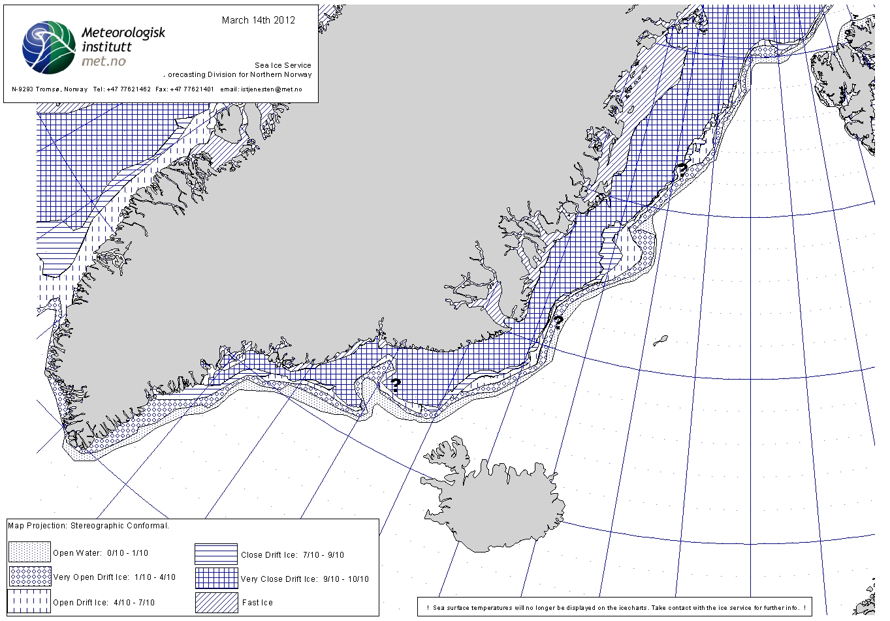

Fig. 1. Drift ice distribution on 14 March 2012 in the Greenland Sea.

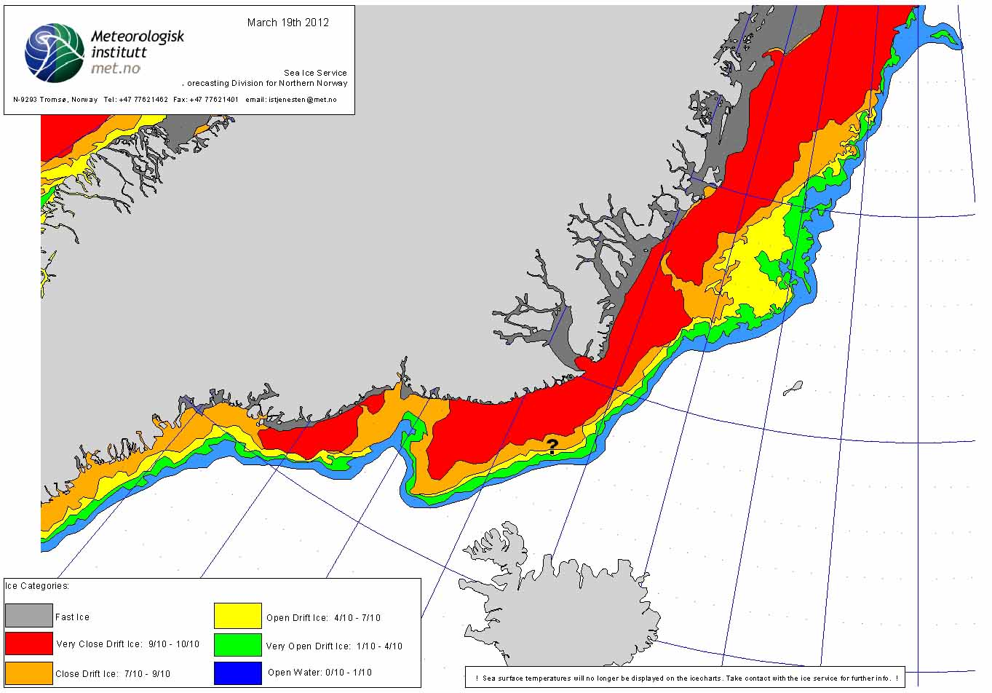

Fig. 2. Drift ice distribution on 19 March 2012 in the Greenland Sea.

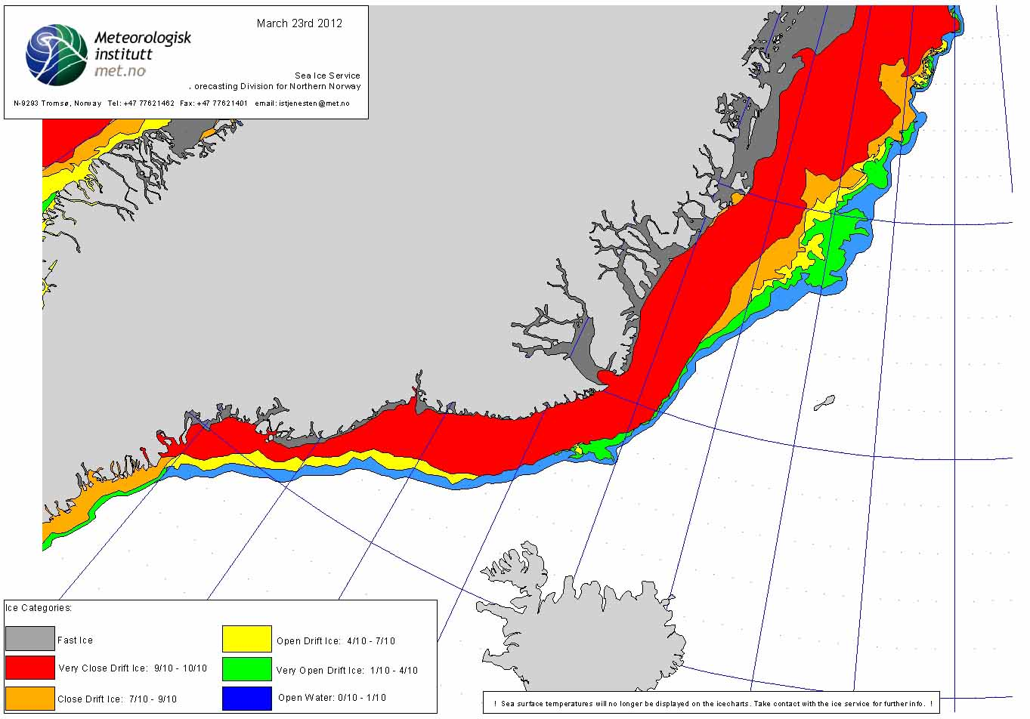

Fig. 3. Drift ice distribution on 23 March 2012 in the Greenland Sea.

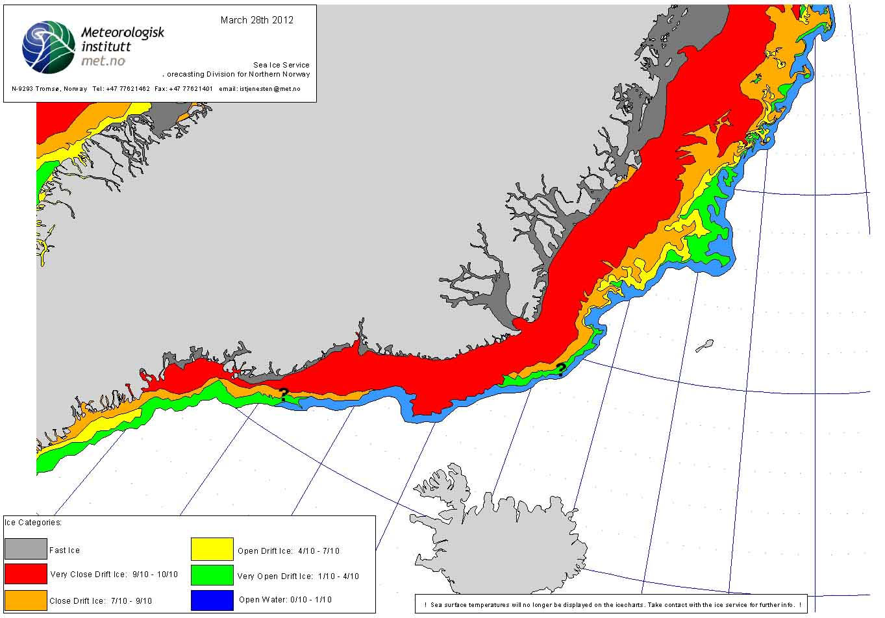

Fig. 4. Drift ice distribution on 28 March 2012 in the Greenland Sea.

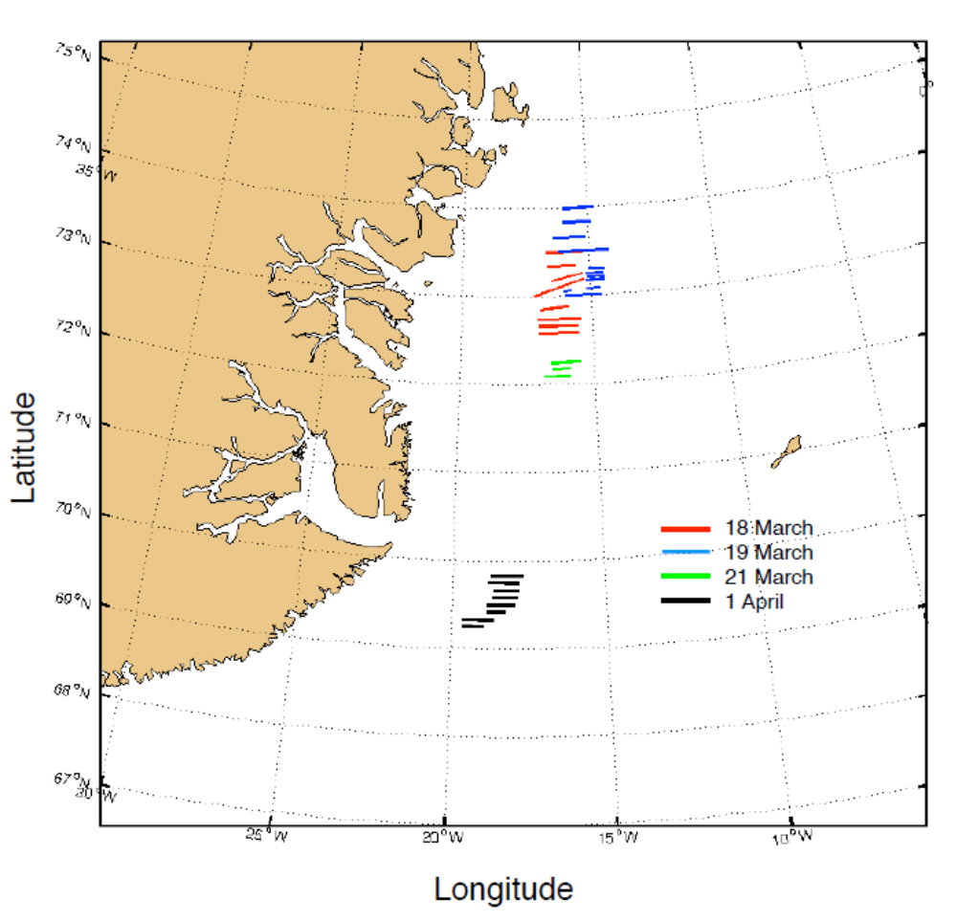

Fig. 5. Reconnaissance surveys conducted by helicopter over the drift ice in the Greenland Sea during the harp and hooded seal pup production surveys in March-April 2012. Transect lines are shown for the period 18 – 21 March and for 1 April.

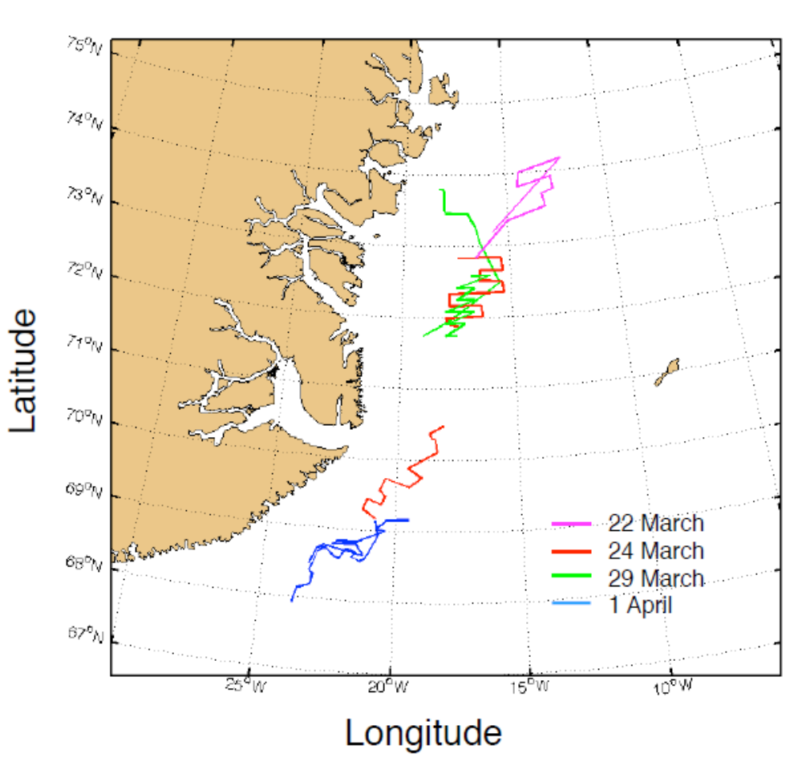

Fig. 6. Reconnaissance surveys conducted by using the fixed-wing aircrafts LN-NPZ and
LN-NAB over the drift ice in the Greenland Sea during the period 22 March – 1 April 2012.

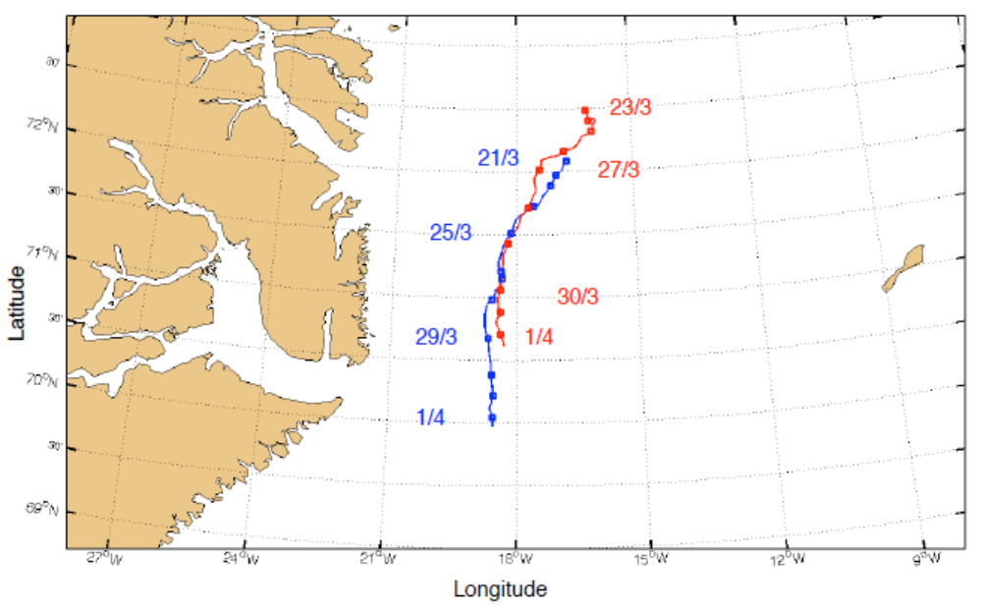

Fig. 7. Ice drift in the Greenland Sea during the period 21 March – 1 April, as observed from two satellite based GPS beacons deployed on the ice on 21 March (in the original patch B, marked with blue) and on 23 March (in the original patch A, marked with red).

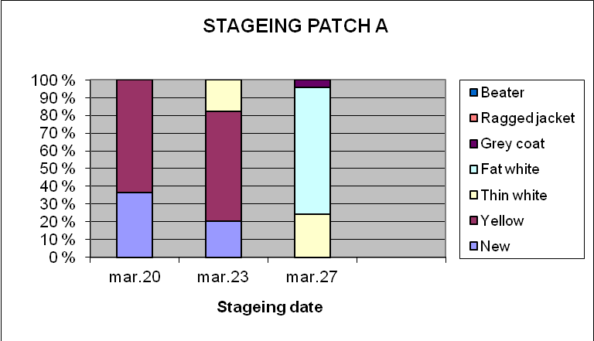
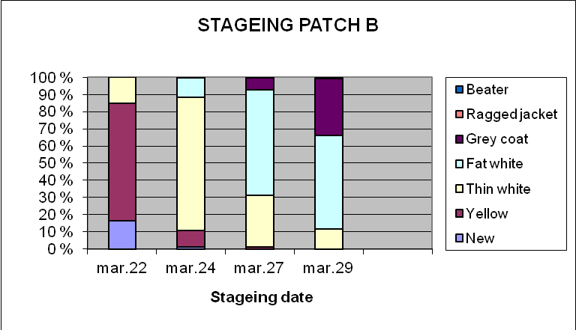

Fig. 8. Distribution of harp seal pups in individual age dependent stages in the whelping patces A and B during March 2012.

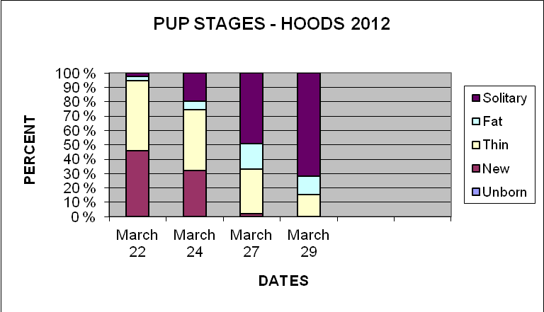

Fig. 9. Distribution of hooded seal pups in individual age dependent stages in the whelping patch B in the Greenland Sea during March 2012.

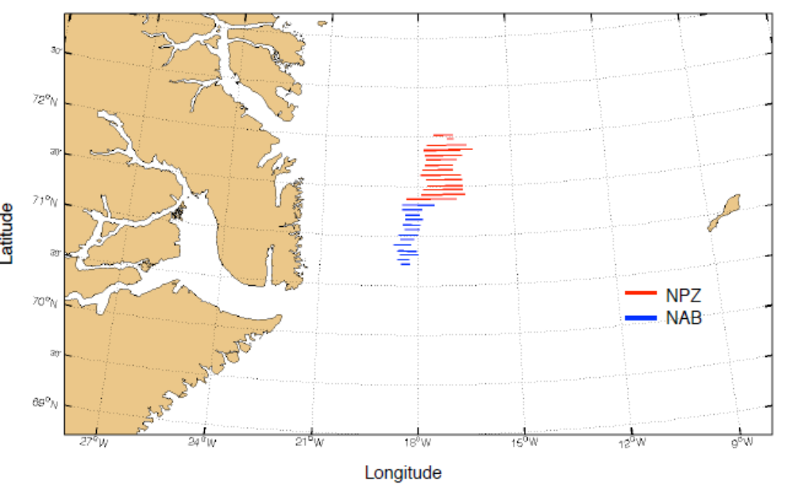

Fig. 10. Fixed-wing photographic surveys covering the harp and hooded seal whelping area on 28 March 2012. Aircraft LN-NPZ covered the northern part (red), LN-NAB the southern (blue) part of the patch.

